KASHIPUR MICHAEL MADHUSUDAN MAHAVIDYALAYA

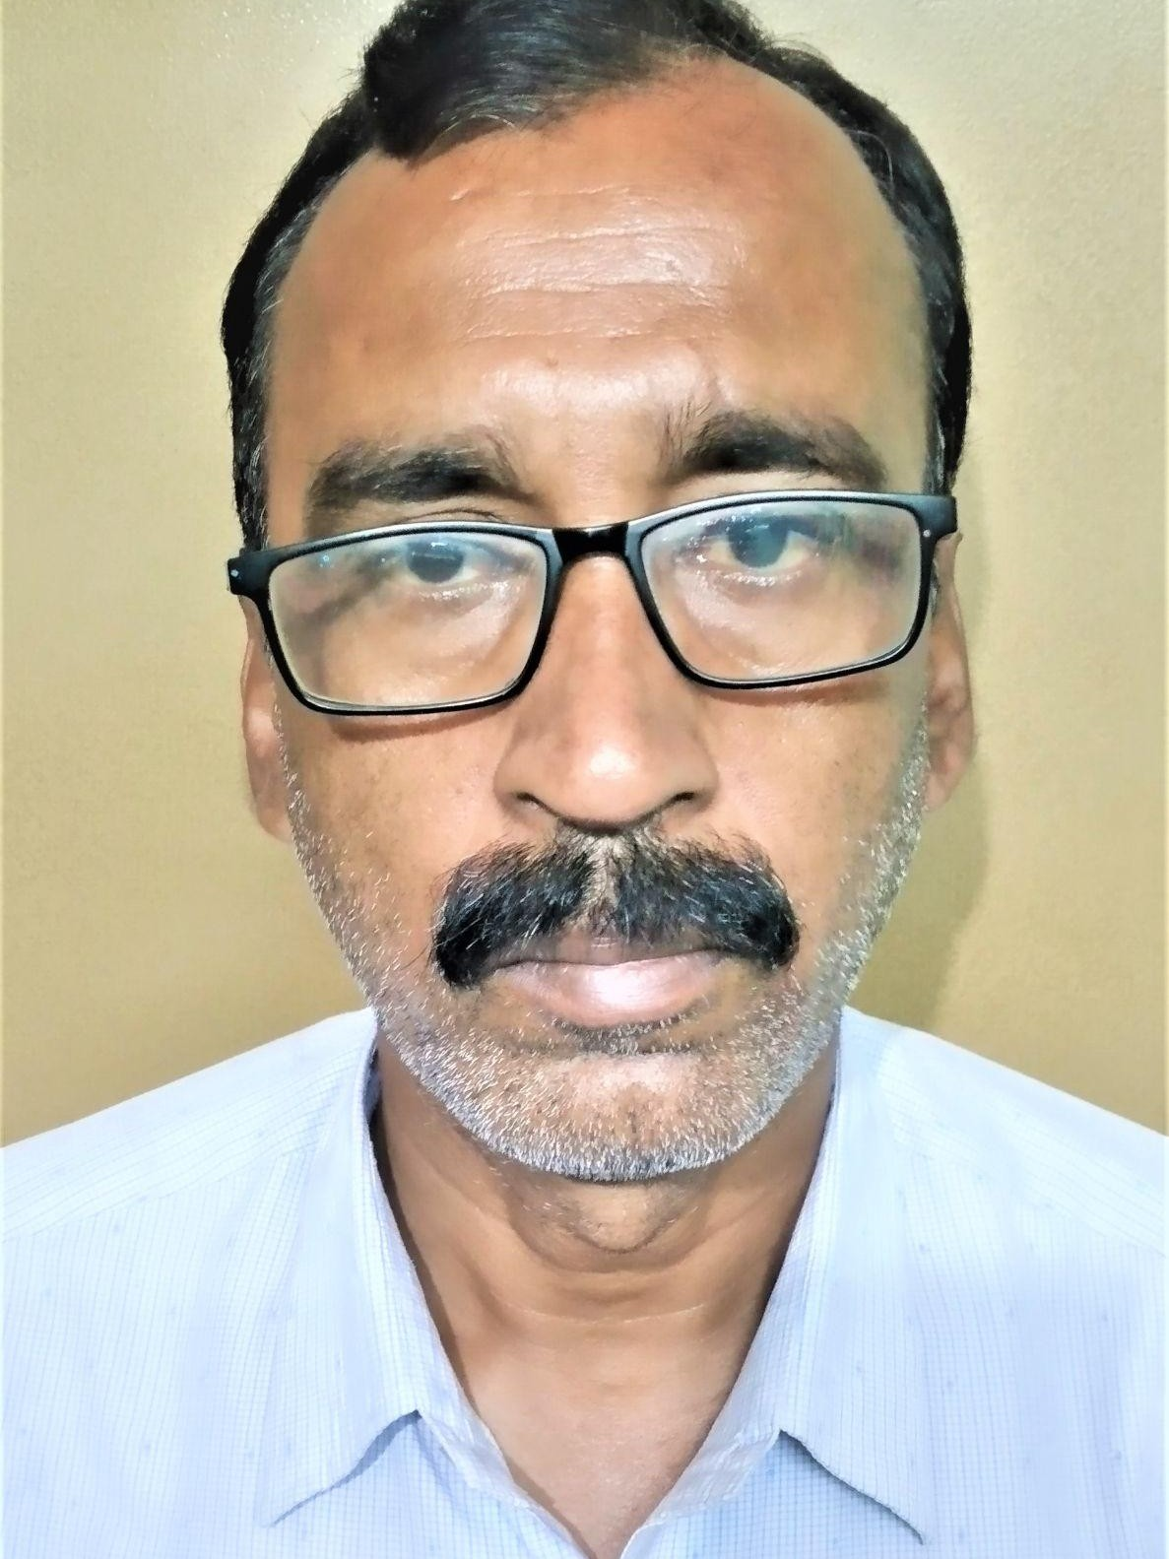
(PERSONAL PROFILE)

Name: Partha Sarathi Mahatha
Designation: State Aided College Teacher(SACT) in Zoology Date of Joining: 01-08-2006
E-mail: parthasarathimahatha22@gmail.com

Educational Qualification:
- M.Sc in Zoology

- B.Ed

Work Experience – 17+ Years of Teaching:
1. KASHIPUR M.M.Mahavidyalaya 01-08-2006 to till date.

National/International Conferences/Seminars/Workshops Attended:

Paper Presentation

1. In ICSSR sponsored International Seminar on “Media, society and culture: Interrelation and Changing Scenario ” held on 25-26th Feb, 2020 organised by the Department of Sociology, Kashipur Michael Madhusudhan Mahavidyalaya,, Puruliya, West Bengal

Participation
- UGC sponsored National Seminar on “CHALLENGES OF COMMON PROPERTY RESOURCES” held on
22-23rd September, 2011 organized by the department of Economics in Kashipur Michael Madhusudan Mahavidyalaya, Purulia, West Bengal, India.

- UGC sponsored National Seminar on “CHALLENGES AND MITIGATION OF DROUGHT IN INDIA ” sept 9-10, 2011 organized by Department of Geography in Kashipur- Michael Madhusudhan Mahavidyalaya, Puruliya, West Bengal.

Training Programmes: NA

List of Research Papers published in National/International Journals/Books/Conference Proceedings: NA

Areas of Specialization/Research/Teaching: Ichthyology

Teaching:

  - Theory
    - First year Pass
    - Second year Pass
    - Third year Pass
  - Practical:
    - First year Pass
    - Second year Pass
    - Third year Pass

